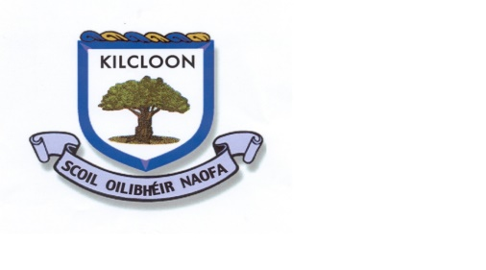
Class: 6th Date: 20-4-2020

Theme for this week:

Keeping Active | Literacy (English & Gaeilge) | SESE | Arts | Numeracy | Jobs around the house/ Free play.
Be sure to get lots of exercise each day and get out and enjoy the lovely weather that will hopefully stay with us for another while. | Continue as you were with a few lines of neat handwriting each day.  Try to read each day, whether that be any books you might have in your house or any of the material available online.  Spellbound (Folens) – activities for the next week of spellings  Reading Zone (Folens) – story on pg 117 and the questions on pg 120 and 121.  (Alternatively, more challenging comprehension questions available on the Folens website – Reading Zone 6th Class - Teacher’s Resource Book – pg128)  A page of free-writing once or twice during the week – any topic that comes into your head.  Sin É (Edco Learning) – An Teilifís – L135, 136,137.  Keep revising your list of verbs in your Irish hardcover. | Small World (Fallons) Geography – pg89 and activities on pg91 and 93 |  | One page of mental maths each day.  IXL – 6th Class – topic of ‘Money and Consumer Maths’  Planet Maths (Folens) Chapter 21 – Money.  Have a go at some of the questions in this chapter if you can.  Maybe play a tables game with somebody at home ! | Continue to help out around the house with any jobs that might make the daily routine a little easier for everyone at home.
Oral Language Opportunities:
Maybe research the positive effects the current crisis has had on the environment and record yourself on a device making an oral presentation on same ?
Extra Resources:

Confirmation Scrapbook – Feel free to continue with one or two sheets of your choice per week. (My own copy of the sheets is in school so I can’t mention specific pages here sorry)

Teacher’s work email: mrcharlie.oconnor1@gmail.com

