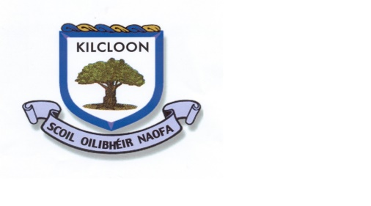
Class: Fifth Class Date: 17/4/2020

Theme for this week: Food

Keeping Active | Literacy English Menu | SESE | Gaeilge | Numeracy | Jobs around the house/ Free play.
This is about making the best of what space and resources you have around you at home. So this is everything from swings and slides, football and basketball, cycling (wearing a helmet), housework and gardening to walking the dog.  Some students have recommended the Joe Wicks online kids workouts.  Share your ideas too! | Reading Zone: Unit 21  Spellbound: Unit 26  Diary: Consider writing entries into your own Lockdown Diary  Procedural Writing: Write out your favourite family recipe in steps- and try your hand at cooking it too!  Poem: Write a poem about your favourite food/baking/restaurant.  Wordsearch/Crossword- Write your own with the theme being Food | Geog: Try Unit 13  France P74-78  Plant a seed:  Google how to try growing one-celery, avocado, potato/sweet potato, pineapple, garlic, onion or tomato.  Let us know if you have any success!  Investigate how foods such as bananas /oranges are transported into Ireland | Bia  Sin E Leigh  L 20:  Bialann Shineach  L27  Bia don Dinnear  Litriu:  Bia agus Deoch  Briathra:  Bris | Firstly and most importantly any maths you do whether from books or online are fine!  Try  Percentages  Topic 17  Have a go at reading the chapter on percentages and maybe try some of the questions. If you are finding it too tricky then some revision of long multiplication and/or long division would be super too. | Time to try cooking and/or baking. Code yourself red/amber/ green and challenge yourself accordingly. If you are new to baking start small!  Enter for Masterchef!!  Remember your entry is not about perfection-its about knowing your own ability and just having a go!
Daily Mile  Challenge  Improve your own fitness level | Oral Language Opportunities: Centred around topic of FOOD  Write up your complete fruit and vegetable list in your English hardback.  Also maybe a list of kitchen utensils- do you know your spatula from your sieve?!  Game: Blindfolded see if you/ and other members of your family can identify various foods.  Baking: Do you have all the vocabulary for baking and cooking-do you ‘knead’ to learn some new words!!
Art:  Try sketching something food related | Extra Resources:  IXL and Epic!  CJ Fallon have free online resources

Teachers work email: mrsmcornyn@gmail.com

