Class: _____Junior Infants_________ Date: 20th-24th April 2020
Dear Junior Infants,
I hope you are all well and I can’t wait to see you all at school when it is safe for us to go back. Until then keep safe and listen to your parents. Try to do some school work each day to keep your brains active. I know you are all clever clogs! Give some of these a try!
Kind Regards,
Ms. Killeen.
Theme for this week: Animals/The Zoo
The following is a list of suggested activities. I have created an online resource called a Padlet which has all the links to websites and activities your child may need. Please use the qr code attached to access it. If you cannot access it please email me. If you wish (no requirement) to take pictures of any work/play your child completes during the week you can send them to my email address. I would be delighted to see some of the great work being done by Junior Infants.
If you have any questions or difficulties with the work I will try to help as best I can. My email address is below.

Keeping Active | Literacy (English & Gaeilge)  Below I have listed the English activities by day as a suggestion (Gaeilge activities are available on padlet) | SESE  (Choose maybe one play activity per day) | Arts/ mindful  (You could do one or two of these over the week) | Numeracy  ( Choose at your own discretion throughout the week) | Jobs around the house/ Free play.
Any activity you can do each day in between completing activities will help you learn better.  Suggestions: Running, jumping, cycling, hopping, skipping, obstacle courses in the garden, ball games, climbing, swinging, sliding.  Websites for PE available on the padlet resource- gonoodle, 10@10, yoga, Joe Wicks. | Monday:  Phonics: Phonics Bloom pick a game to practice phonics (padlet)  Reading: Reading a-z Pick a decodable reader to read. (padlet)  Activity Book: Can do next available page(could be page about Zack)  Tuesday:  Phonics: Phonics pop game (padlet)  Reading: Tricky word Bingo (padlet) If you can’t print stick or put something on the words on the screen to make it like bingo.  Can do a decodable reader on padlet if time allows  Writing: Practice cursive writing of the words: dad, lad, lag, wag, old, dog. Can use online resources on padlet to help.  Wednesday:  Phonics: Phonics play (distinguishing between real and fake words ) (padlet)  Reading: Reading a-z pick another decodable reader.  Activity book: Can complete next page.  Thursday:  Phonics: Starfall games an and at. (padlet) Make words ending in an and at.  Reading: Tricky word bingo- do a different card today.  Writing: Practice cursive writing of individual letters u,y,v,w,l (use padlet resources to help) Small bit of practice for 10 minutes.  Friday:  Phonics: CVC word game – click on the option to let me sound it out.  Reading: a-z reading- pick a decodable reader or go over ones done already.  Activity book: Next page | Learning Through Play:  Your child could use their teddies or toys that are animals and play with them. (Make a zoo, organise the animals into categories eg cats, water animals, monkeys etc  Your child could play working at the zoo- feeding the animals, cleaning and caring for the animals, being a vet to the animals, caring for a baby animal.  Beebots- the children have used these mechanical bees in class. Try using them online on padlet to develop their coding skills.  Use lego/blocks etc to make a zoo add in features such as cages, open areas, picnic areas, gift shop, ticket desk, zoo train etc  If you have playdough/morla/clay your child could make some animals using it eg giraffe, tiger etc ( get pictures of these animals from books or the internet to help them) | Music:  Any songs and nursery rhymes you would like to sing are available on padlet resource.  See can you find a song about the zoo.  Taking care of our minds section on padlet. May help with some children’s anxiety during this time.  Art:  Draw/colour/ paint a picture of your favourite animal. Create a zoo.  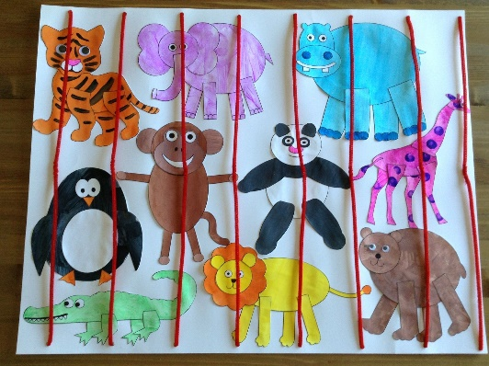  Some other animal art and craft ideas here.  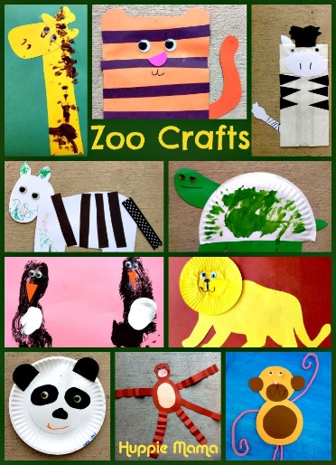 | Children could use animals and teddies as a Maths opportunity. Write numbers 1-5 on cards and see if they have one- elephant or 2 of any animal etc.  Count how many animals they have.  Using chalk or crayons or water and a paint brush practice writing numbers 1-5 on tarmac or gravel outside if possible (pencil and paper will work too)  Complete some pages from number practice book.  Choose a maths activity from padlet each day.  Use any toys or items around the house to make sets of items eg put 5 teddies together, put five coins together, 5 balls, 5 pieces of lego, 5 crayons. Etc try for 4,3,2,1 . | Please help your mum and dad with little jobs- tidy up your toys, be kind to brothers and sisters, dress yourself each morning, brush your teeth etc.  Play and have fun at home with all the wonderful toys and games I know you all have.
Oral Language Opportunities:
Ask your child to tell you about what they made/did during play. Here is some language that may come up when playing the Zoo.
Tickets, ticket office, animals, monkeys, tigers, lions etc, train, vet, feeding, food, water, grass, reptiles, teeth, claws, legs etc
Extra Resources:
The Grow in Love website is available to parents. You already have the login details. If you wish to look at Theme 8: Water is Wonderful feel free to.
Teachers work email: niamhkilleen123@gmail.com
This is the qr code for the padlet (online resource) Please email me if it is not working for you.
https://padlet.com/niamhkilleen123/gnain5mlbal7
Please note there are extra websites and games on the padlet which we will be using over the next few weeks of distance learning. Feel free to look through them if you wish.

