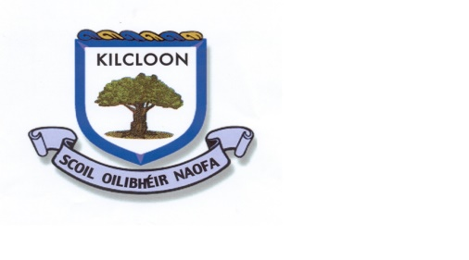
Class: Second Date: 20th April 2020

Theme for this week : Food

Keeping Active | Literacy (English & Gaeilge) | SESE | Arts | Numeracy | Jobs around the house/ Free play.
- Practice your favourite sport for 10 mins each day.  - Measure how far you can jump and how fast you can run 20 metres and try beat that each day. | - Write a list of all the stories you know that have a type of food in the title.  - Make up 5 questions to ask someone who owns a chocolate factory.  - Write a story about a magical food (Like the magic beans from Jack and the Beanstalk)  - Write down a recipe for your favourite meal/food.  - Design your own Siopa as Gaelige. (Template provided) | - Pick 5 countries from around the world and find out about their national food. Write a short piece about it.  - Make a list of 10 types of healthy and 10 types of unhealthy foods. Write a little about why a food is healthy or unhealthy. | - Pick an item of food from your house, put in front of you and then draw or paint it.  - Draw a plate of food for your favourite meal. | - Complete adding/subtracting healthy food sheet  - Solve shopping maths problem | - Plant some seeds  - Help water plants around the garden.  - Learn to cook a new meal.  - Tell someone at home a new fact you have learned each day.  - Help out with tasks at home.
Oral Language Opportunities:
Talk about everybody at homes favourite food.
Make a video of you giving instructions for cooking your favourite meal- Just like a celebrity chef!

 | Extra Resources: Siopa template, maths healthy food sheet, maths problem sheet.

Teachers work email: mrohora1@gmail.com

